**DATA STRUCTURES AND ALGORITHMS**

**LAB-03**

|  |  |
| --- | --- |
| **Name** | Syed Sohaib Shah |
| **Reg n.o** | 200901040 |
| **Batch/Section** | BS CS-01(A) |
| **Date** | 10/22/2021 |

**Task-01**

**Program + Output:**

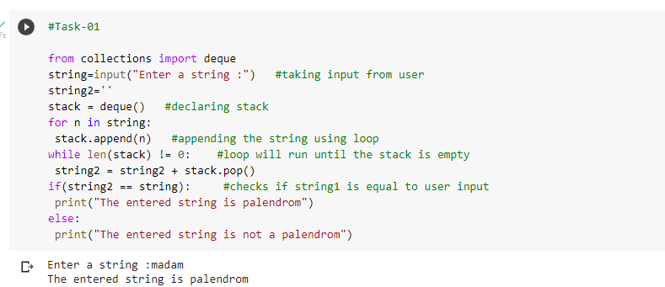

**Task-02**

**Program + Output:**

